a.

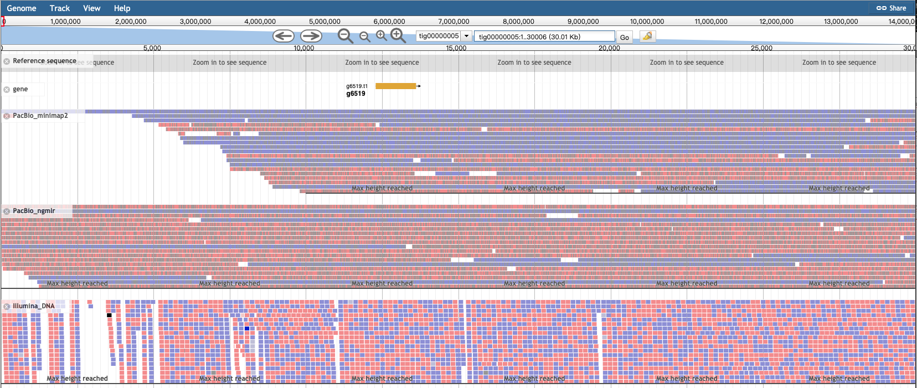

b.

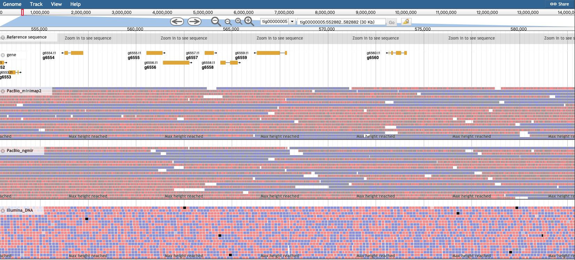

c.

g6564

g6559

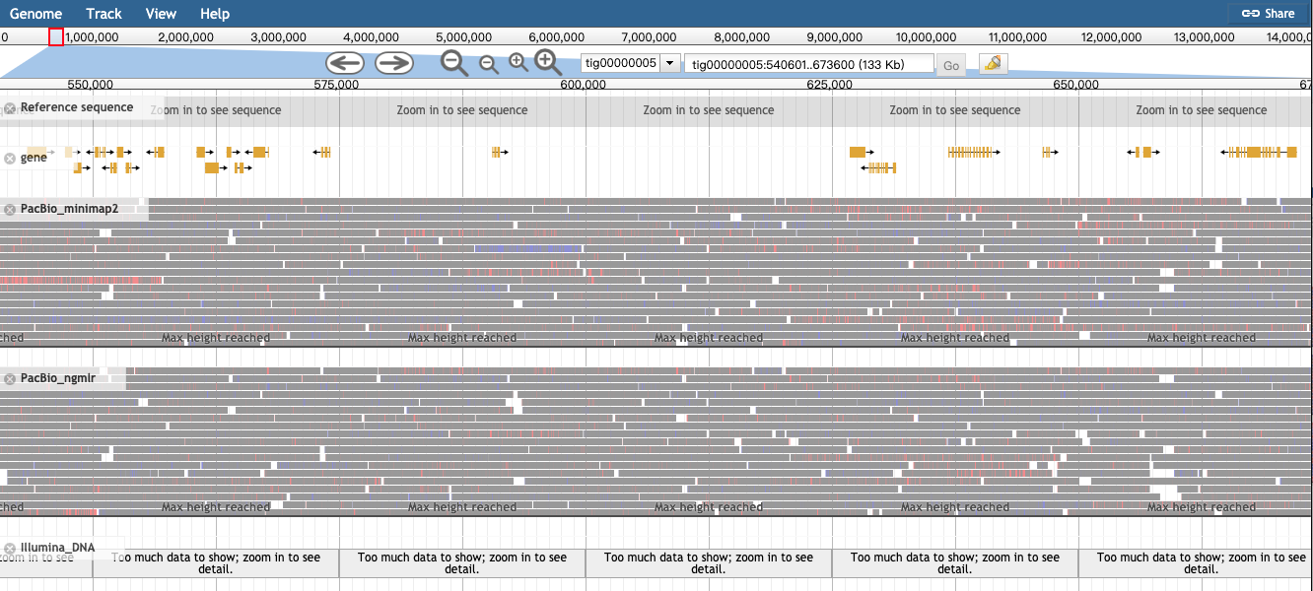

HLP

VGT Gene

Figure Sx. tig00000005: 0-30 kb jbrowse shotcut. A) g6519 is PpCF, B) g6559 is HLP, C) g6564 is a VGT gene, which is a amidase family protein. PacBio_minimap2 and PacBio_ngmlr tracks are PacBio subreads mapped to liwanxian genome by minimap2 and ngmlr. Illumina_DNA track is Illumina short reads mapped to liwanxian genome by bwa mem.